Cable configuration
The green drive tubular linear motors are provided with signal and power cable ready to be connected to different servo drive.
Two set of connectors are used M23 (power) and M17 (signal) speedtec and M15 (ytec) for smaller motors.
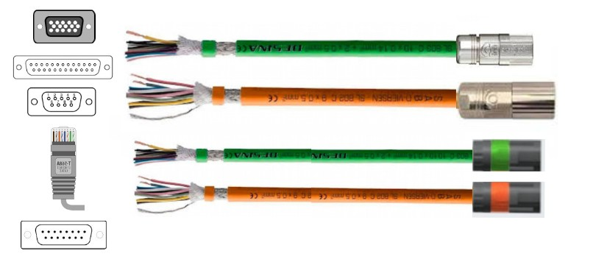cables.jpg

SIN/COS 1Vpp or BiSS with incremental output lines without thermal sensor (thermal sensor on the poower cable)

Signal cable (flying leads => DE20000780 for M17 connector and DE20000361 for M15 connector on motor side)
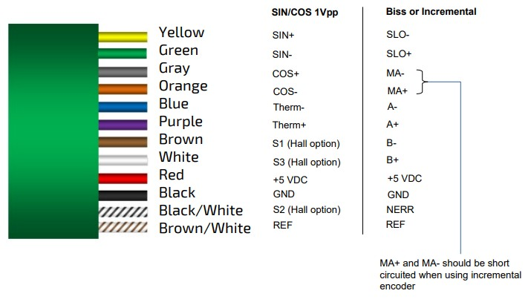signal_cable.jpg

Hall signal for commutation option
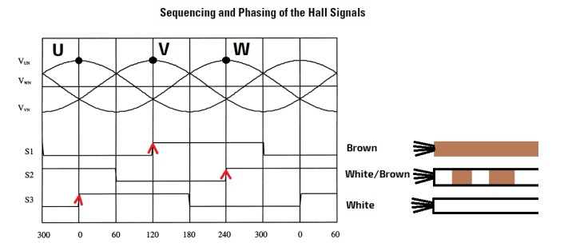hall_signal_option.jpg

BiSS without incremental output lines with thermal sensor
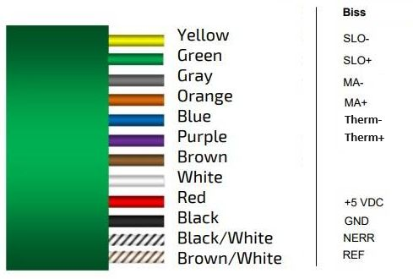biss_therm.jpg

Power cable (flying leads => DE20000771 for M23 connector and DE20000352 for M15 connector on motor side)
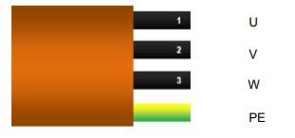power_cable.jpg

