Antirotation mechanics
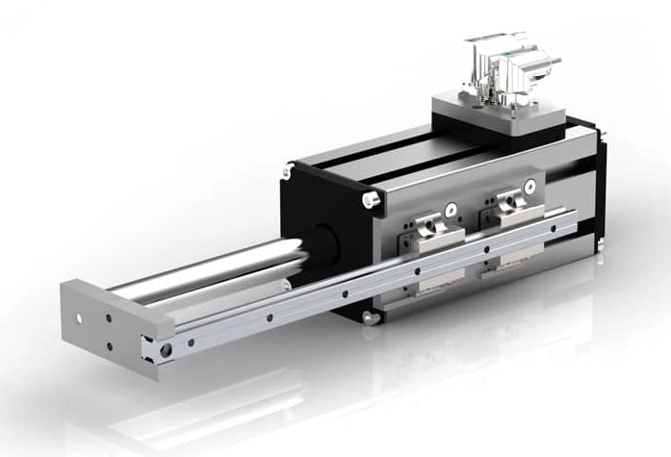gd_anti.jpg | 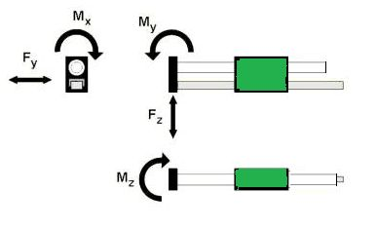bending_dir.jpg
Force and momentum ratings
Parameter | GD160D/T/Q | GD250D/T/Q/X | GD350D/T/Q/X/E
Fy [N] | 248 | 1000 | 1480
Fz [N] | 248 | 1490 | 2450
Mx [Nm] | 44 | 192 | 360
My [Nm] | 77 | 435 | 720
Mz [Nm] | 77 | 275 | 445
Lifespan [km] | > 90.000 | > 100.000 | > 90.000
Note that this lifespan is considering a lubrication interval of 5000 Km each 6 months.
Theoretical value calculated considering miniature linear guide size 12 and 15 and standart linear guide size 15

Bending rating
Extension [mm] | 60 | 160 | 260
Bending [mm] per motor size | GD160D/T/Q
Fz = 5 N | 0.004 | 0.081 | 0.34
Fz = 10 N | 0.012 | 0.151 | 0.65
Fz = 20 N | 0.021 | 0.300 | 1.31
Bending [mm] per motor size | GD250D/T/Q/X
Fz = 10 N | 0.005 | 0.029 | 0.11
Fz = 10 N | 0.008 | 0.049 | 0.22
Fz = 20 N | 0.010 | 0.109 | 0.46
Bending [mm] per motor size | GD350D/T/Q/X/E
Fz = 20 N | 0.002 | 0.019 | 0.089
Fz = 40 N | 0.005 | 0.039 | 0.179
Fz = 80 N | 0.009 | 0.079 | 0.359

