GDiR - ISO Rotolinear
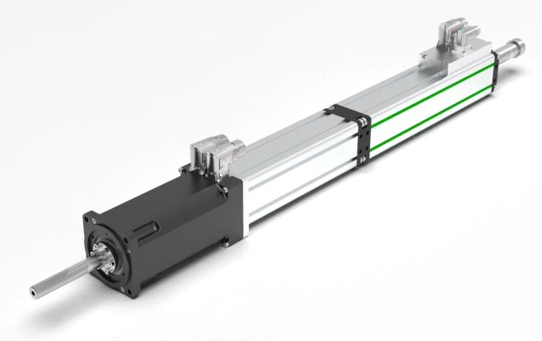gdir250xs.jpg
Ideal for closing, screwing, and assembly tasks, GDIR linear rotary motors are defined by their superior speed and adaptability.
This innovative design houses two electromagnetic servo motors in one sleek unit, making complex linear-rotary motions easier than ever to achieve.
Operating Principles & Key Features
- High-Performance Drive: Utilizes highly dynamic direct-drive technology for both linear and rotary axes.
- Dual-Axis Control: Execute independent movements or fully synchronized motion paths as needed.
- Total Command: Fully programmable control over press forces and torque levels.
- Custom Configurations: Available with optional hollow shafts for media feed-through or Maglift integration for efficient load compensation.

