Maintenance

General preconditions
Before starting up the drive please follow this check list, respect all safety instruction and notes below:
- Check all electrical connections and all mechanical components and their safety operation
- Check availability of all supply involved with servo driver/controller
- Check the safety warranty of people involved with machine operation
- Check the proper installation of the motor
- Check the correct power connection between the motor and the drive
- Check the function of limit switch, over-travel switch where available
- Check function of emergency brake or stop
- Check machine mechanics arrangement (mechanical installation)
warning_symbol.jpg | Danger to life, heavy injury or damage by failure or malfunction on mechanical or electrical components!  Risk of injury or danger to life, as well as damage due to nonconformity of warning and safety notes!

General start-up procedure
For general startup procedure of integrated drive motors please refer to NiLAB's Starter Software section.

Maintenance and check of motor components
Integrated drive linear motors are maintenance free components but due to external influences the motor can be damaged during operation. This result in preventive maintenance of the motors with service intervals on machine side checking all parts involved:
- Check the state of stator and the slider
- Check screws and connections
- Check the state of power and signal cables
- Check the state of linear guides (mechanical components) evaluation wear and state of lubrication when used
Suggested maintenance schedule for applications
PHASE | LESS THAN 150 MOV/MIN | FROM 150 TO 300 MOV/MIN | MORE THAN 300 MOV/MIN
Startup | Check | Check | Check
After 3 months |  | Check | Check
After 6 months | Check | Check | Check

Maintenance activities
Check
Please consider the following checklist:
1) Is the motor shaft clean?
2) May the motor shaft slide freely?
If the above conditions are not met, please proceed with the cleaning.
Cleaning
It is recommended not to use solvents, kerosene or similar products and to consider the following checklist:
1) Remove the shaft from the motor body dismounting the stop ring at the ends
2) Clean the shaft with alcohol and a soft cloth
3) Clean the internal parts of the motor body with compressed air to remove contaminants
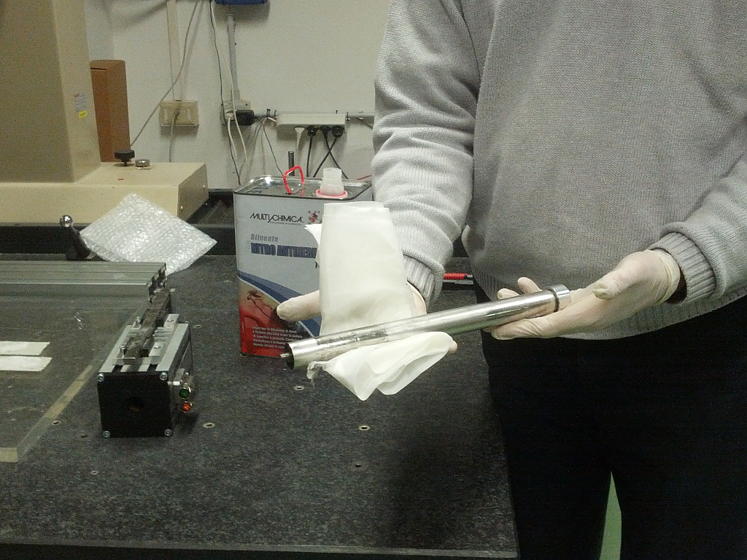
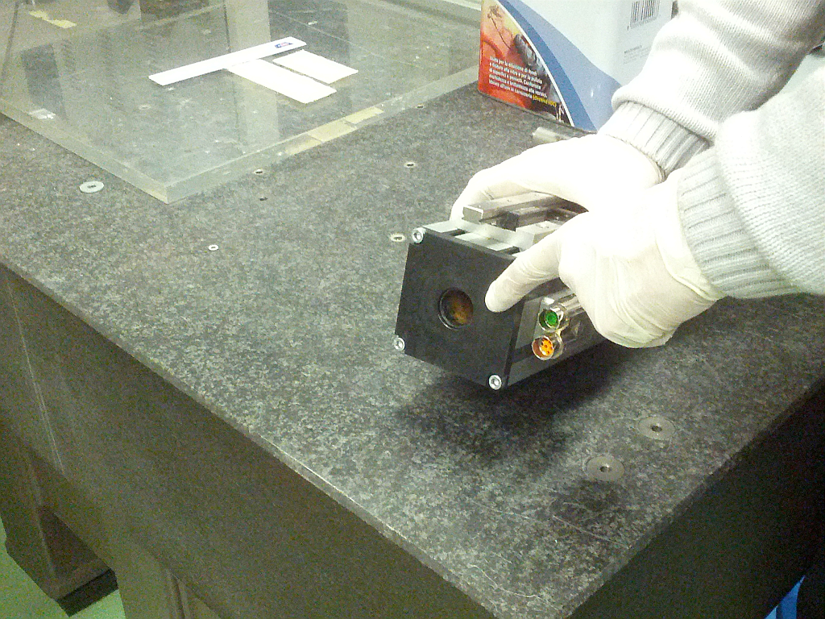​​​​​​
Instructions for lubrication
The polymer sliding bearings are lubrication free bearing. So, there is no need to use lubricants.

