Actuator lubrication
The linear motor is guided with WON recirculating ball linear guides. The linear guide block are equipped with LF Seals designed to avoid lubrication on the end customer side.
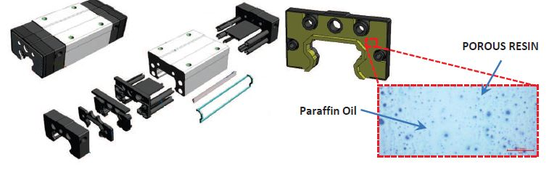lf_photo.jpg
The lubrication is guarantee using porous resin containing lubricant. This lubricant improves drammatically the lurbication interval.
The GDM linear stage integrates 2 x H20RUU + LF option. With this technology the carriage can run for very long time without lubrication.
Typical value is more than 192 times the standard lubrication interval.
Please do not use grease lubrication in GDM stage. Grease lubrication is not optimal with high speed linear motion.

LF lubrication seal test
Please see attached information: :gdm_linear_axes:lf_seal_tank_2.pdf

RohS Cerfication
The RoHS cerfication about the LF seal is here: :gdm_linear_axes:lf_seal_approved_by_rohs.pdf

Maintenance
WON guides allow for extended maintenance intervals; provided below are the estimated inspection example schedules.
Stroke [mm] | Mov/minutes | Axis duty cycle | Check intervals
250 | 40 | 7/7 24/24 | 2-2,5 years
500 | 82 | 7/7 24/24 | 1-1,5 years
Please on check activities:
1) Axis smoothness check
2) Check the lubrication due to LF seal ⇒ if the lubrication is not effective replace the LF seals with new one.

