Connection system

Power cable - DE20001270-5M
The GDM linear unit is provided with two cables: power cable with PTC sensor connections.
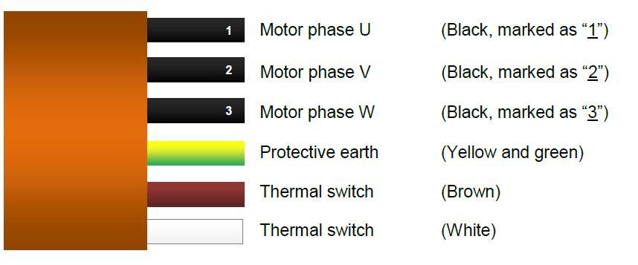l_series_1.jpg
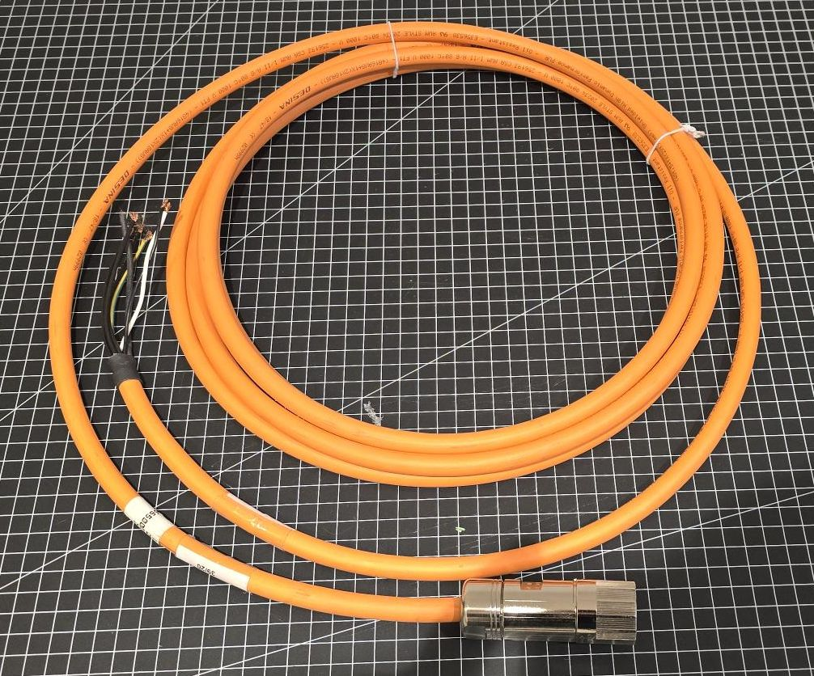
Note: The thermal switch connections can be also in black color. In this case the cross-section of these wires are smaller than the motor phase wires.

Signal cable
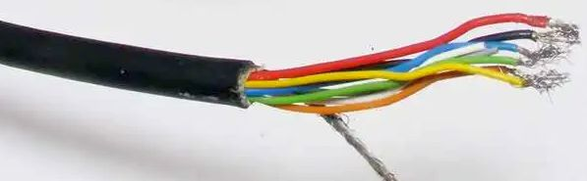lika_cable.jpg
Note: This signal cable can be provided with the connector type used from the servo drive.
Function | Cable wire colors
0 VDC | Black
+5VDC +/-5% | Red
SIN+ | Yellow
SIN- | Blue
COS+ | Green
COS- | Orange
Shielding | Shield

