Safe Torque Off

Manual switch (Emergency button)
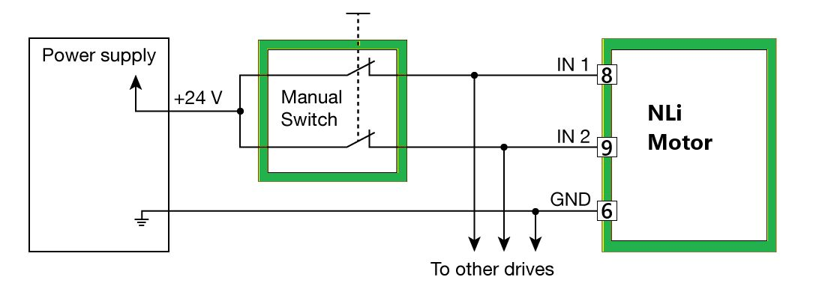sto_example_1.jpg

Safety PLC
For example: Safety PLC output or safety sensors (e.g. Safety light curtain, safety scanner etc.)
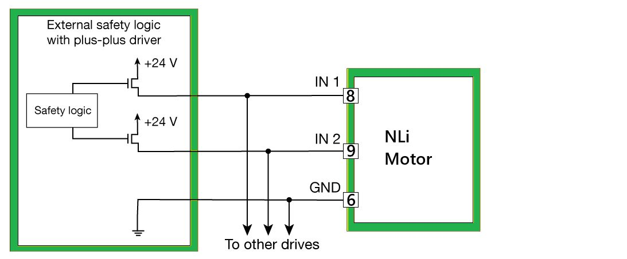sto_example_2.jpg

