Two kind of software interface are available for programming EPULSE servo dirive: ByInterface for general configuration and commitioning and Motolab starter for commitioning of applications

NiLAB ByInterface - Software for parametrization
Download link: https://www.nilab.at/download/nilab-byinterface-10-4-0-epulse-and-mbd-drive/?wpdmdl=6966&refresh=654c8643e112a1699513923
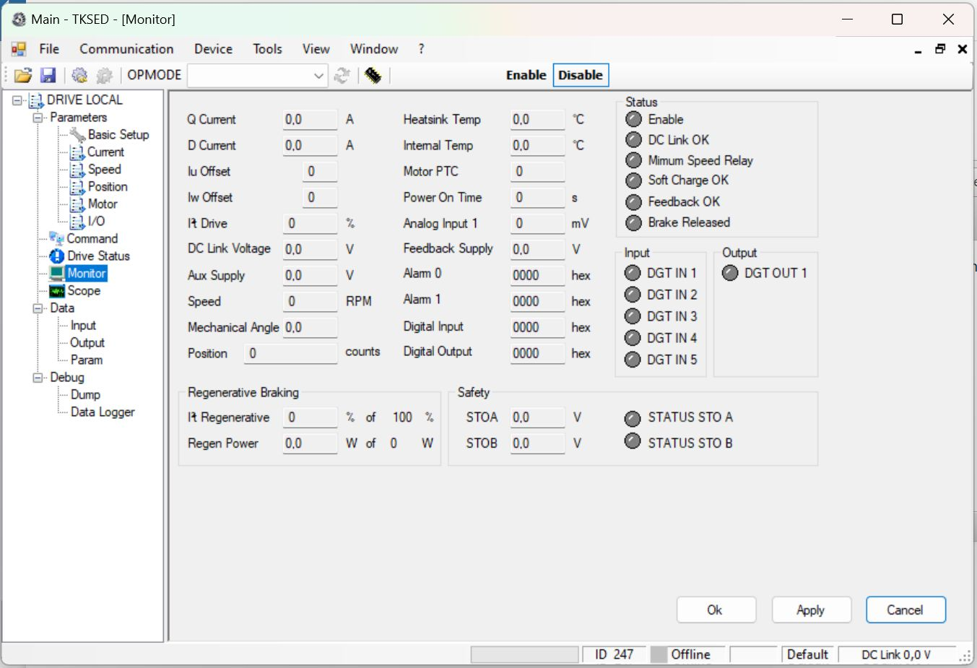byint.jpg

MotoLAB Starter - Software for application configuration
Download link: https://www.nilab.at/download/motolab_starter_ver0-0-1-0/?wpdmdl=6631&refresh=654c8643db4f81699513923


