Epulse50 Motor feedback connection
Epulse50 is able to work with 3 different types of motor feedback:
1. Resolver
2. SIN/COS 1Vpp (1 sine period per 1 shaft rotation)
3. ABZ + Hall
4. Hall only
5. Variable reluctance resolver (on request)
6. Sensorless (on request)
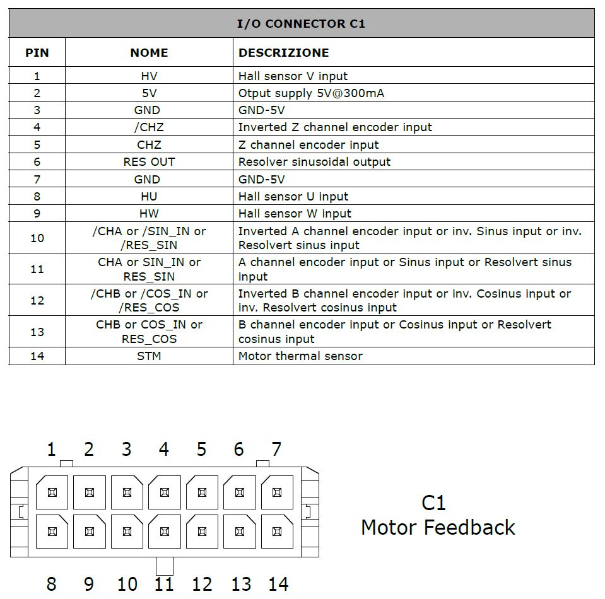moto_con.jpg
Port | Ordering Code | Brand | Description
C1 | 43025-1400 | Molex | 14 poles male, for motor feedback (Receptacle Housing)

