Epulse100 Mechanical Dimensions
3D Model (Step format): :epulse50_dc_servodrive:ftd100_20200331.zip
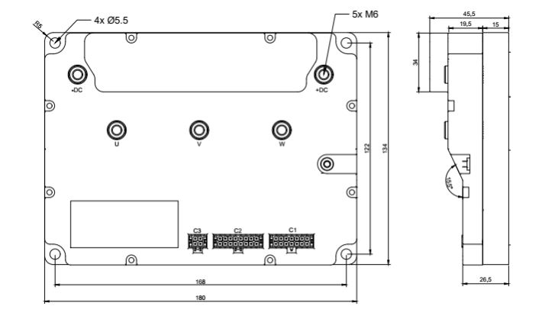epulse100_dimensions.jpg

