Epulse50 Mechanical Dimensions
3D Model (Step format): www.nilab.at/dokuwiki/lib/exe/fetch.php?media=epulse50_dc_servodrive:d-ftd50-0003-3.zip
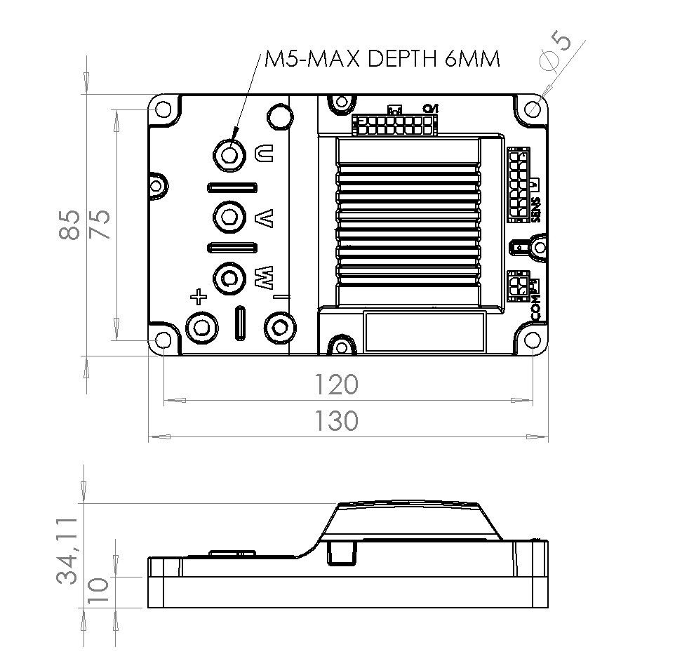epulse_drw.jpg

