Epulse50 Connectors

IMPORTANT: In order to avoid damages, please use 2.2Nm max of Tightening torque for U,V,W, + and - connectors.

Position and function
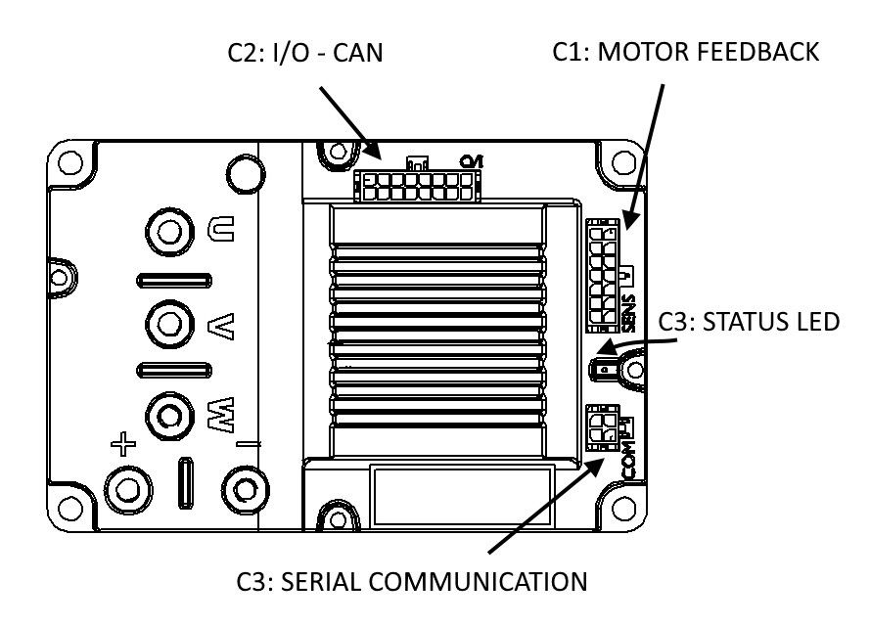conn_epulse.jpg
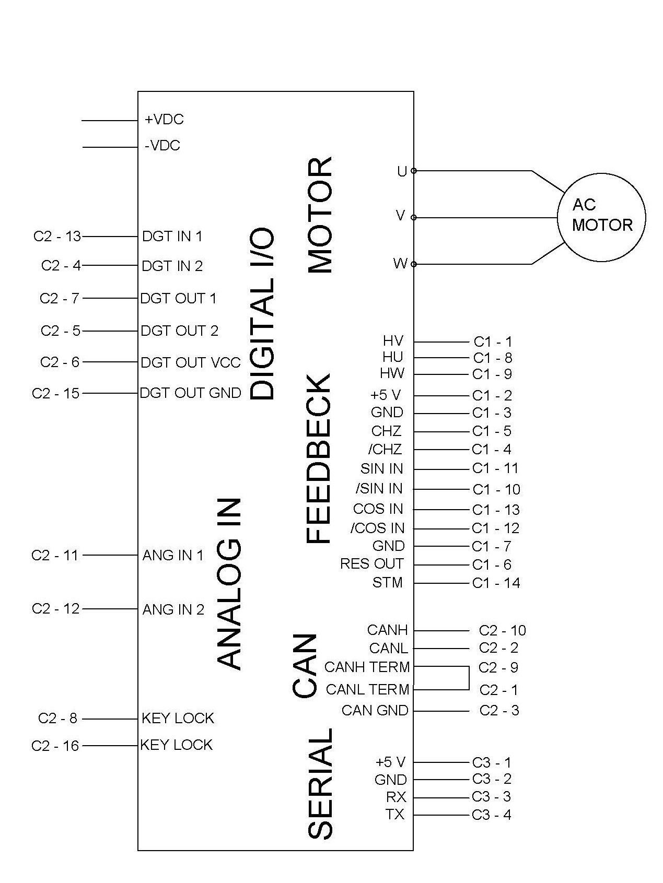conn_epulse_1.jpg

Connector types
Port | Ordering Code | Brand | Description
C3 | 43025-0400 | Molex | 4 poles male, for serial communication (Receptacle Housing)
C2 | 43025-1600 | Molex | 16 poles male, for input/output/can (Receptacle Housing)
C1 | 43025-1400 | Molex | 14 poles male, for motor feedback (Receptacle Housing)
– | 43030-0007 | Molex | Crimp Terminal, 20-24 AWG
– | 79758-0010 | Molex | pre-Crimped Lead Micro-Fit 3.0 Female-to-Micro-Fit 3.0 Female Tin Plated, 300mm, 20AWG
– | 11-03-0043 | Molex | Etraction tool
– | TTL-232R-3V3-WE | NiLAB | UART/TTL3V3 Converter

