Epulse30 Connectors
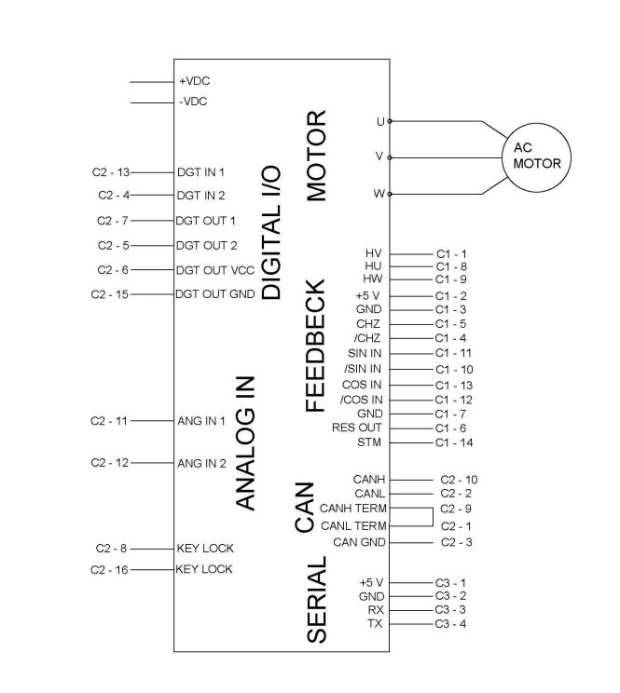epulse30_con.jpg

Connector types
Port | Ordering Code | Brand | Description
C3 | 501939-0400 | PicoClasp | 4 poles flying, for serial communication (Receptacle Housing)
C2 | 501189-2010 | PicoClasp | 20 poles flying, for input/output/can (Receptacle Housing)
C1 | 501330-0800 | PicoClasp | 8 poles flying, for motor feedback (Receptacle Housing)
- | 501193-7000 | PicoClasp | Crimp Terminal, 20-24 AWG
– | 079758-1017 | PicoClasp | Pre-Crimped Lead MicroClasp Female, 300mm, 28AWG
– | TTL-232R-3V3-WE | NiLAB | UART/TTL3V3 Converter

