USB Programming cable
Product code: TTL-232R-3V3-WE
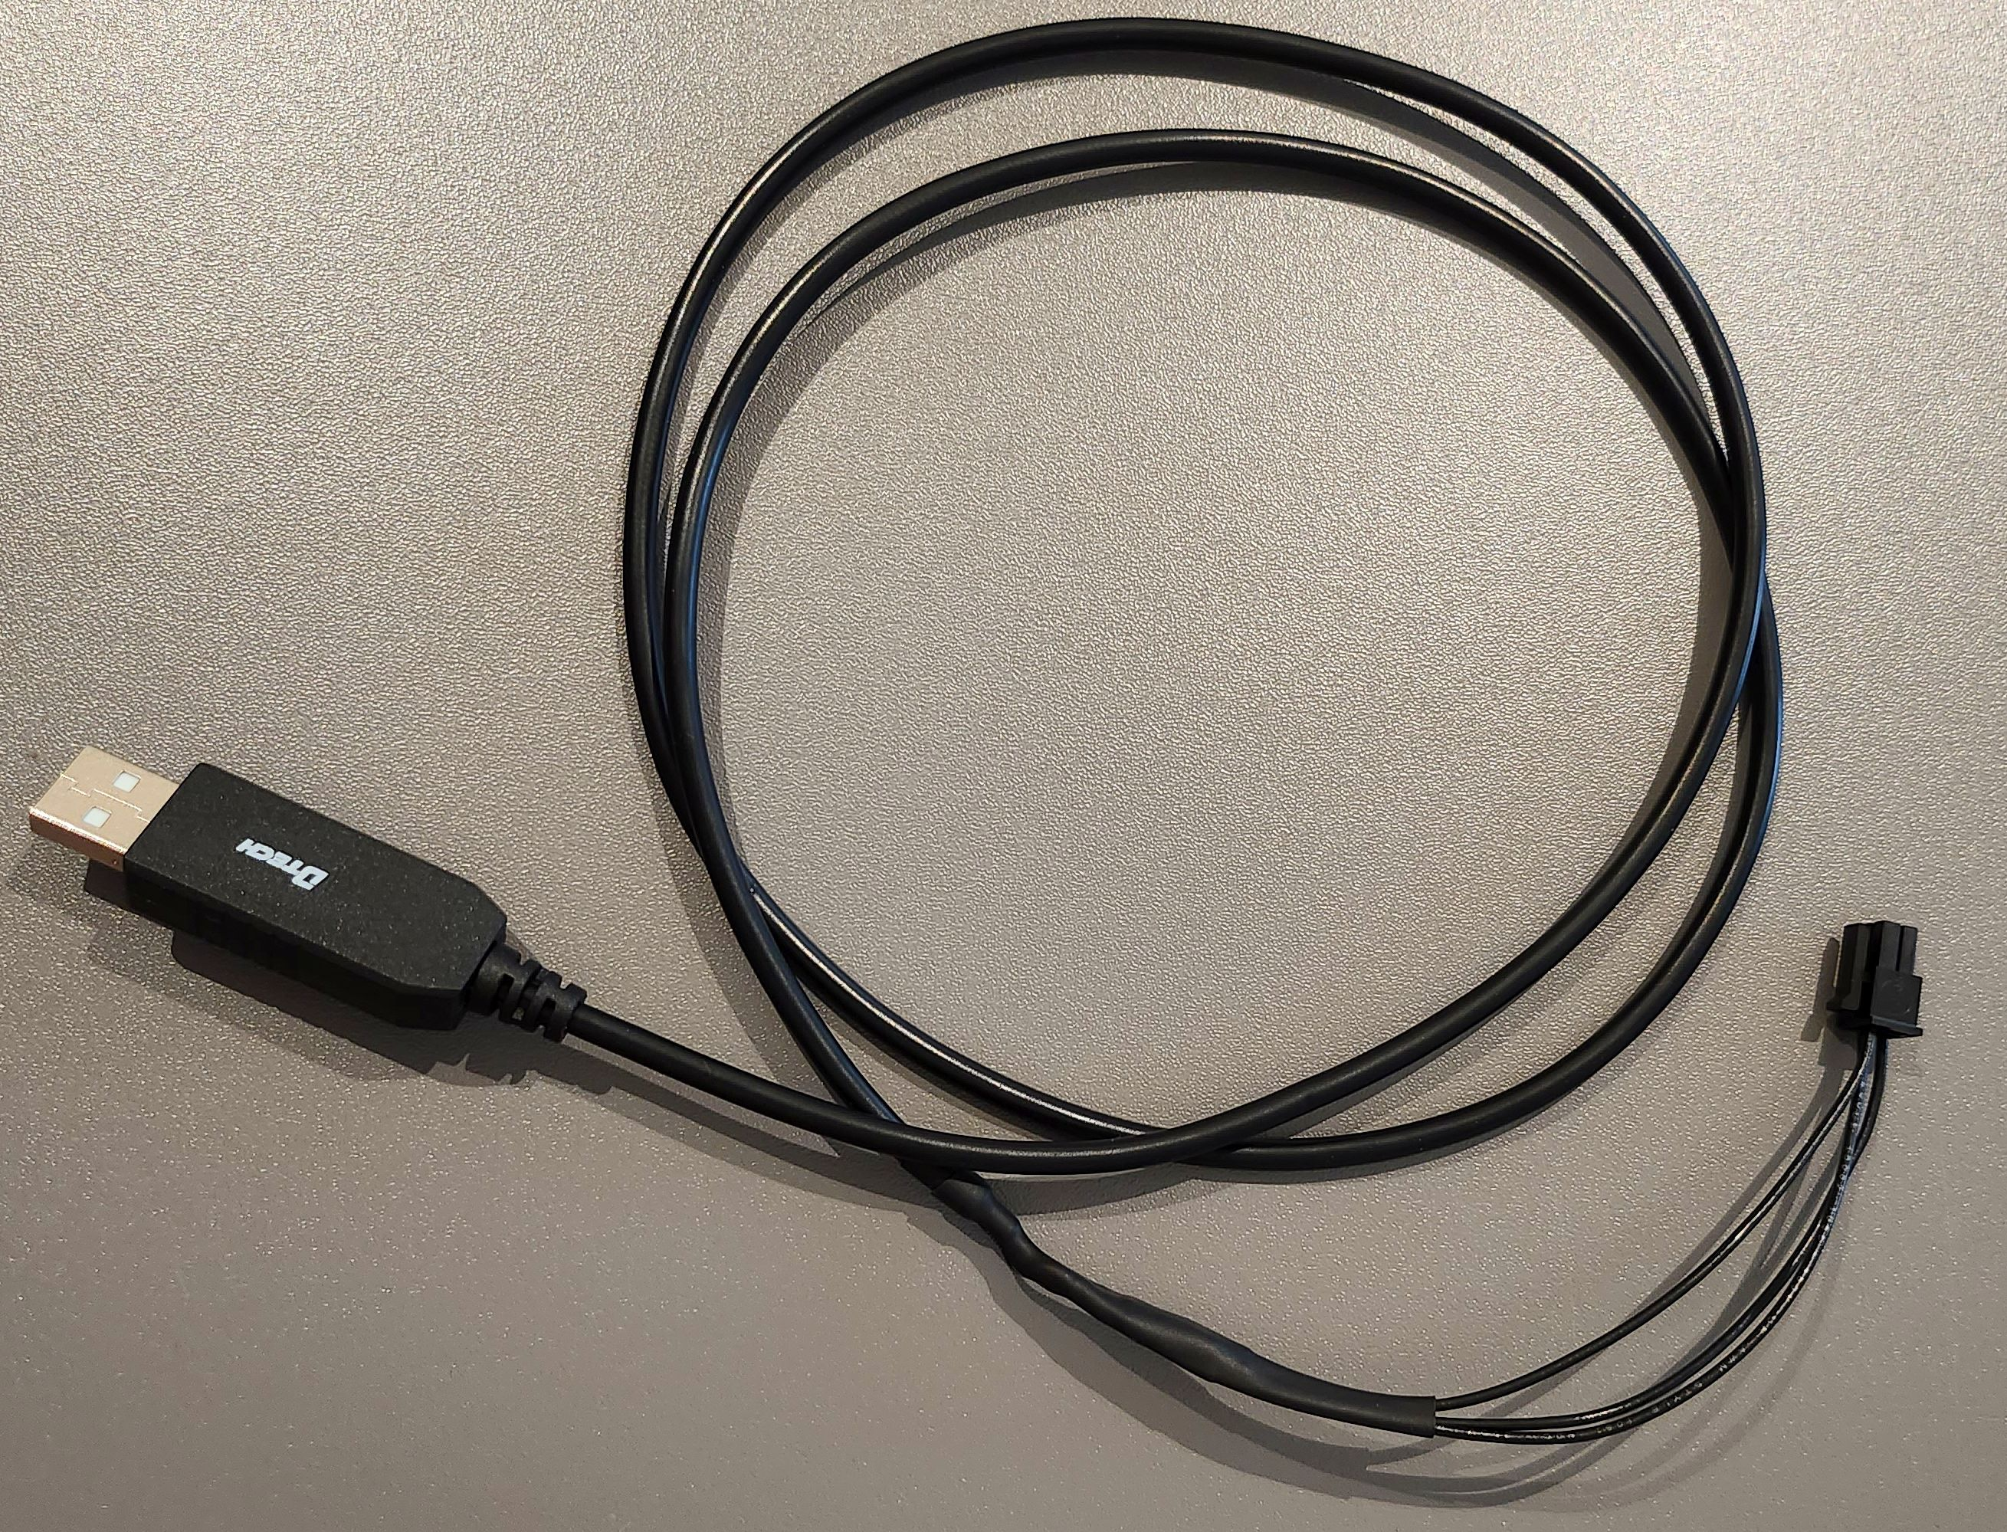cable_photo.jpg

Connector kit for encoder, I/O and CAN
Product code: EPULSE50-CONNKIT K-CONN


