Engineer´s Guide
Technical resources for automation designers and system integrators — from motor sizing to fieldbus integration.
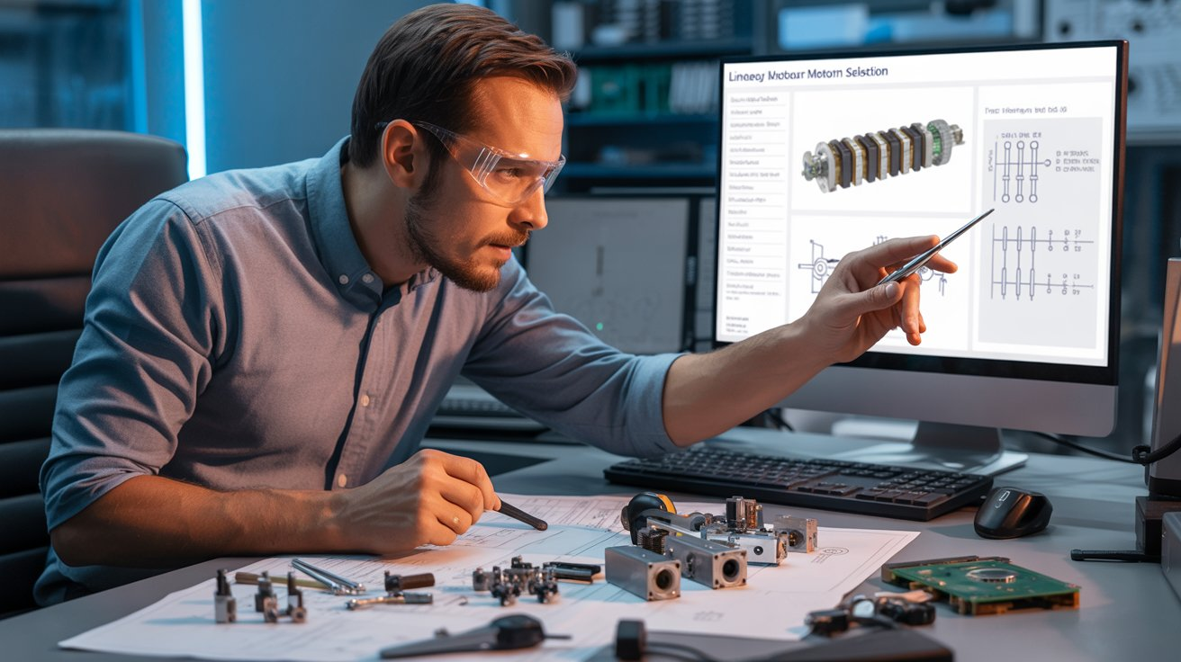engineering_guide.jpeg

